# Pre-Requisite:

1. Visual Studio
2. Outlook

# Code Setup Steps:

1. Download the zip file and extract all content.
2. Open visual studio 2019 in admin mode
3. Open the .sln file from downloaded path
4. Go to physical path of file “\Outlook-AddIn-POC\Addin.Outlook.UI\PushToEpicFormRegion.resx”

* Right click to open properties
* Check the unblock icon and click Apply button.

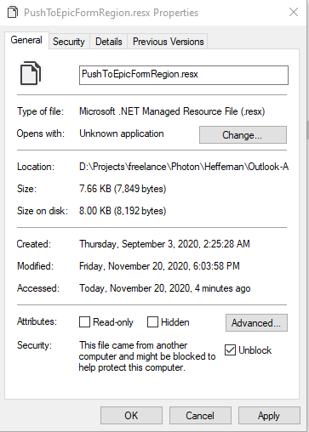

1. Right click and open Properties of “Addin.Outlook.UI” project

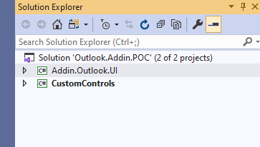

1. Go to “Signing” section and click on “Create Test Certificate”

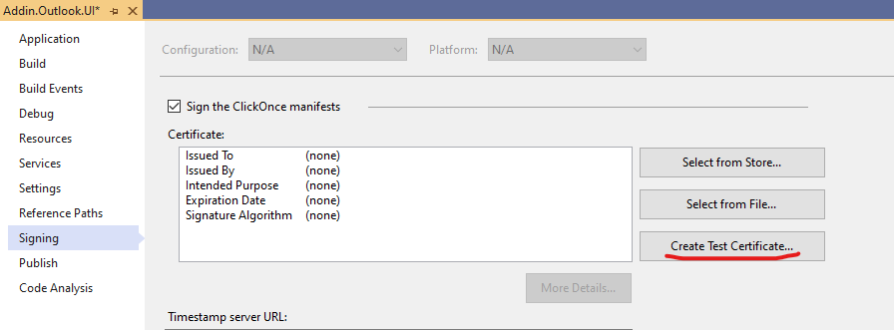

1. Provide any password like “Pasword123” and click OK.

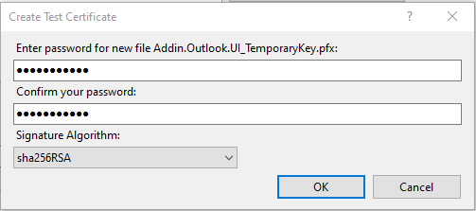

1. Rebuild solution in Debug mode
2. Make “Addin.Outlook.UI” as startup project
3. Click the Start Button

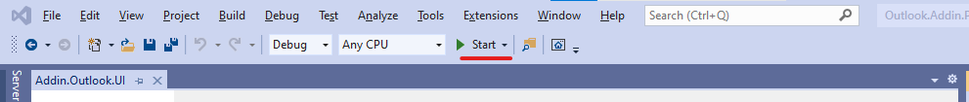

1. It should come up like below:

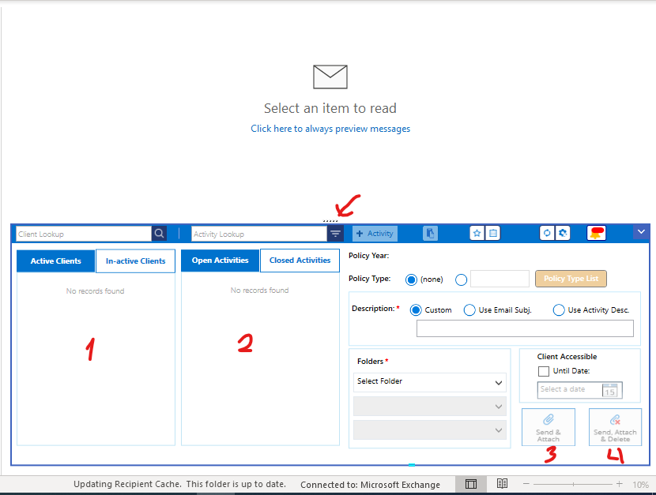

1. Close the outlook.

# Reproducing Error

1. Go and Change display scaling to 125%

* Right Click and Desktop and open “Display Settings”

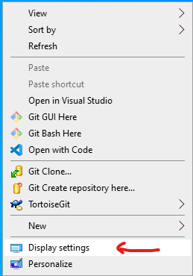

* Change Scaling to 125%

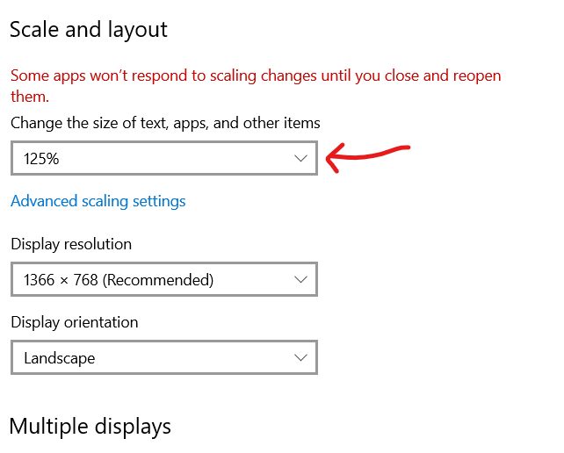

* Now Run from Visual Studio again



* It will not show the Buttons which were there earlier. You can easily identify the Buttons marked as 3 and 4 are missing or dripped down. Also the height of the control from dots is easily visible.

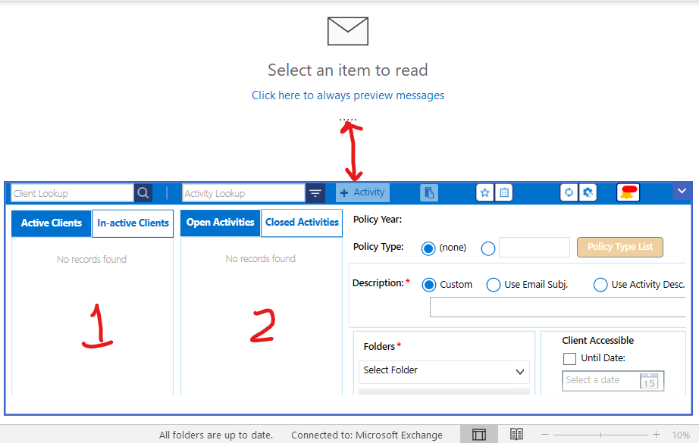

Difference in View:

